ScopeSteps Project Proposal
Version 0.1 | 10 October 2026 | College capstone proposal
Project title: ScopeSteps — Agentic Product Scoping and Technical Planning Platform
Status: proposed full platform, delivered through staged milestones. This document preserves the original platform ambition while making authority, evidence, estimation, and integration boundaries explicit. Team names, course details, and submission requirements are to be supplied by the student team before submission.

1. Executive summary
ScopeSteps is an AI-powered web platform that helps product owners and project leads turn meeting discussions, project documents, company knowledge, and repository evidence into reviewable project scope and structured backlogs. It combines source traceability, clarification, stakeholder decision-rights management, technical recommendations, controlled scope changes, and phased Jira integration.
The platform supports the work of a Product Owner, Technical Architect, and Engineering Lead; it does not independently inherit their organizational authority. Agents may gather evidence, ask questions, draft plans, and propose changes. Authorized users approve commitments, estimates, and external publishing. This is bounded autonomy rather than unreviewed control over a team's work.
The initial one-week POC tests the platform's foundation: transcript and brief → clarification → cited backlog → approved baseline → one proposed scope-change diff → approved export. Repository ingestion, advanced planning, and bidirectional Jira sync remain part of the full platform roadmap, not requirements for that first milestone.

2. Problem, users, and objectives
Project intent is distributed across meetings, documents, stakeholder conversations, and implementation knowledge. Converting it into actionable work is vulnerable to missed requirements, unsupported assumptions, contradictory decisions, loss of provenance, and uncontrolled changes. A discussion item may be mistaken for an approved commitment; regenerated plans may overwrite human decisions.
Primary user: a Product Owner or project lead responsible for preparing scope and coordinating approval. Supporting users: stakeholders supplying business context, engineers reviewing technical feasibility, authorized approvers, integration administrators, and read-only reviewers. Expertise, administrative access, and authority to approve scope are separate concepts.
Objectives:
– Preserve the distinction between decisions, proposals, exclusions, rejected ideas, assumptions, and unanswered questions.
– Produce actionable backlog drafts whose requirements and significant acceptance criteria can be inspected against source evidence.
– Reduce unsupported commitments and human correction effort relative to a simple single-pass AI baseline.
– Maintain an approved scope baseline and make later changes explicit, attributable, and reviewable.
– Connect approved planning work to execution tools without losing audit history or overriding external edits silently.
These are project hypotheses and evaluation goals, not claims of proven productivity gains or market demand. APM's change-control guidance supports the workflow of recording, evaluating, approving/rejecting, and implementing changes to an approved baseline. [1]

3. Full platform capabilities
Capability | Proposed behavior
Multi-source ingestion | Import transcripts, text/PDF documents, authorized wiki content, and repository context through controlled parsers/connectors. Version inputs and preserve access restrictions.
Source audit hub | Inspect original/normalized sources and the exact passages behind requirements, criteria, decisions, and integration outputs. Flag superseded or inaccessible evidence.
Stakeholder profiles and decision rights | Extract candidate identities/roles for confirmation. Users assign subject-specific approval rights; the agent does not infer authority from title or speaking frequency.
Product scoping and backlog generation | Separate commitments from suggestions, ask clarifying questions, and draft epics/stories/tasks with testable criteria, dependencies and explicit assumptions.
Technical planning assistance | Explain repository-supported observations and propose implementation approaches with evidence. Distinguish unverified recommendations from reviewed/tested conclusions.
Planning scenarios | Estimate effort, resources, delivery, and potential ROI only from explicit capacity, dependency, cost, historical and benefit assumptions. Show uncertainty or insufficient information.
Visual hierarchy and review | Navigate backlog relationships, source links, blockers, drafts and approved versions; edit with clear ownership and revision history.
Conversational scope control | Analyze additions/removals against the approved baseline, propose a targeted diff and impact notes, and require approval before applying changes.
Jira integration | Progress from approved one-way publishing to conflict-aware two-way synchronization with permission checks, external mappings and recovery from partial failures.

Jira hierarchy is configuration-dependent: standard software work commonly follows Epic → Story/Task/Bug → Subtask. Initiatives/additional levels above Epic depend on plan/configuration. ScopeSteps adapts to the existing project rather than rewriting its hierarchy. [2]

4. End-to-end workflow and approvals
1. Authorized users create a project, identify decision owners, and upload/connect sources.
2. ScopeSteps versions and indexes permitted content, identifies candidate requirements, and exposes conflicting or missing decisions.
3. The agent retrieves evidence and asks targeted questions; answers become attributed project evidence.
4. Users inspect the proposed backlog, supporting passages, assumptions, dependencies, and technical recommendations.
5. An assigned approver accepts an exact version. Approved scope becomes an immutable baseline.
6. New requests produce candidate changes, not immediate edits. Reviewers see additions, modifications, removals and affected dependencies.
7. Approval creates a new baseline. Export/publishing is a separately authorized operation; rejected changes leave the baseline unchanged.
8. Later integrations reconcile execution updates under explicit field-ownership and conflict rules.
Role model: Viewer, Editor, Approver, Integration Administrator, and Workspace Administrator. Roles may be combined for a small team, but administrative privilege does not silently grant business approval rights. High-risk production approvals may require a second person; a solo capstone exception must be disclosed.

5. Architecture and technology direction
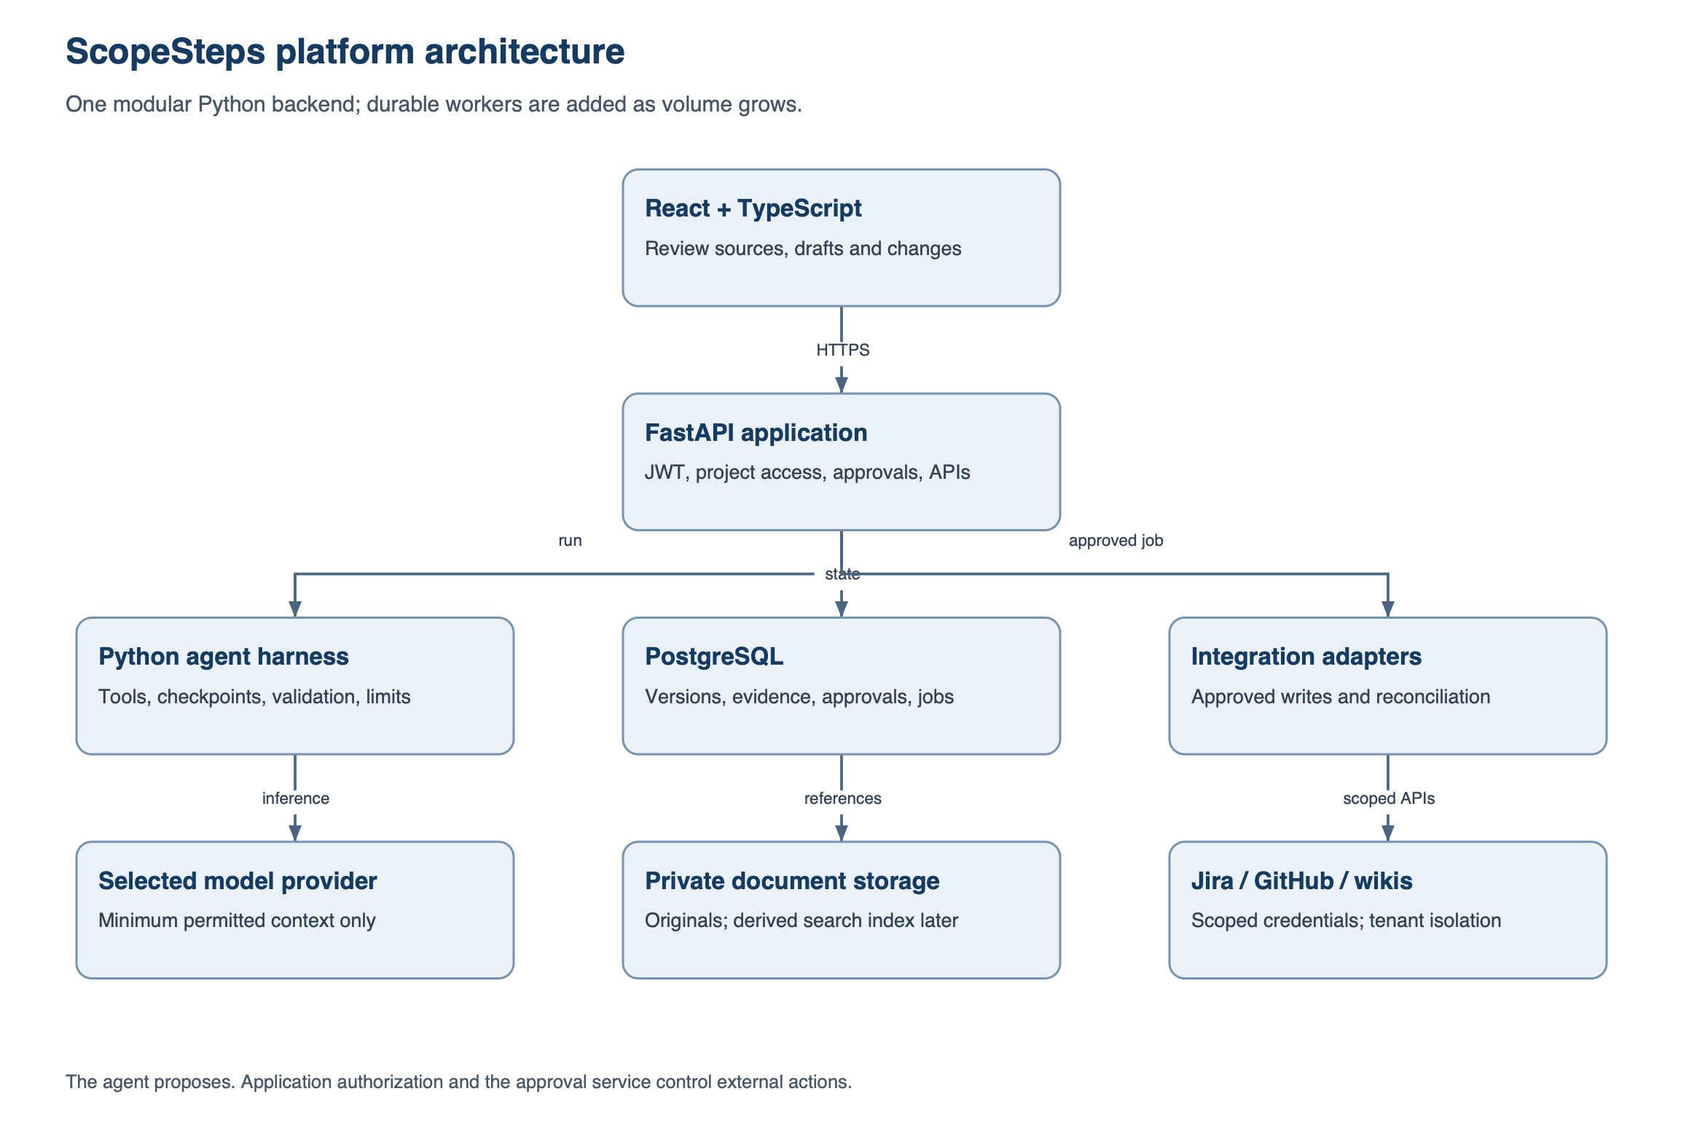
ScopeSteps platform architecture
Layer | Proposed direction
Frontend | React + TypeScript, with a responsive source/backlog/change-review workspace.
Backend and agent | Python + FastAPI; modular application with a bounded, tool-calling agent harness.
Validation and persistence | Pydantic, SQLAlchemy/Alembic, PostgreSQL for the platform; lightweight local storage for the POC.
Knowledge storage | Private original-document storage and versioned source blocks; add evaluated hybrid/vector retrieval when necessary.
Model access | Provider adapter; evaluate a free-tier model using synthetic data, with explicitly approved alternatives and budget controls.
Integrations and jobs | Scoped connector adapters, persistent job state, approval-controlled outbox and later durable workers.

An agent harness manages context, permitted tools, state, validation, pause/resume, limits and telemetry. The project uses existing models; it does not train a foundation model. Start with one agent and clear domain services. Evaluate orchestration frameworks when durable branching/interrupts justify them. [3]
Local development and an optional free-tier demo are distinct from production deployment. Free hosting may sleep, lose local files, limit capacity, or pause inactive projects. Free chatbot access is not free API access; real provider quotas/privacy terms must be checked. The Technical Proposal compares Cloudflare/Render/Supabase, local inference, and a costed AWS alternative.

6. Required safeguards and quality attributes
Area | Requirement
Decision integrity | Confirm authority, classify discussion accurately, and escalate unresolved conflicts rather than applying numerical authority guesses.
Traceability | Use stable source/item IDs and immutable versions. Identify source-backed claims separately from AI-proposed details and human edits.
Baseline safety | Require exact-version approval; preserve human changes; reject stale/concurrent updates and retain previous approved versions.
Privacy and access | Project isolation applies to retrieval, citations, exports and integrations. Synthetic data is the capstone default; real data needs explicit permissions/provider policy.
Agent safety | Restrict tools and budgets; treat uploaded instructions as untrusted; never allow the model to grant approval or retrieve unrelated projects.
Reliability | Persist run progress, expose failures, bound retries and reconcile ambiguous external writes rather than promising exactly-once delivery.
Usability | Clear evidence navigation, accessible controls, visible uncertainty and understandable error/recovery states.
Honest planning | Forecasts expose assumptions and uncertainty. Repository access alone is not proof of technical feasibility.

7. Phases and deliverables
Phase | Deliverables and exit condition
P0: initial one-week POC | React/FastAPI/Python flow from two text sources through clarification, cited backlog, approval, one change diff and export; evaluated against a simple baseline.
P1: core platform | Authenticated projects, confirmed roles, durable storage/runs, source audit hub, versioned visual backlog and approved one-way Jira publishing.
P2: broader intelligence | Wiki/repository/PDF ingestion, evaluated retrieval, technical-review evidence and input-based planning scenarios.
P3: platform hardening | Conflict-aware two-way sync, operational recovery, security/privacy review, calibrated planning and broader user evaluation.

The POC is a milestone, not the final product. Its one-week deadline is a scope constraint, not a guarantee that every desired feature will fit. Detailed checkpoints, fallback scope and engineering tasks belong in the separate POC Implementation Plan.
Final capstone deliverables, within the agreed phase boundary: working dashboard/API/agent, versioned source and approval model, documented integration behavior, repeatable tests/evaluation, architecture/API documentation, and a demonstration with limitations. Planned capabilities must not be presented as implemented.

8. Evaluation
Create a manually reviewed synthetic benchmark covering straightforward decisions, rejected ideas, missing information, conflicting sources, scope amendments and instruction-like malicious text. Hold back examples from development. Review semantic requirements rather than exact story wording/count.
Compare the bounded agent with a single-pass assistant using the same original sources and model settings. Also provide final clarification answers to the baseline in a second comparison, separating the value of new information from the value of orchestration.
Metrics: confirmed-requirement coverage; unsupported commitment rate; citation-support accuracy; appropriate clarification/conflict handling; correctness of changed-item sets; preservation of unrelated approved work; human correction effort; latency, tool/model calls and cost. Run authorization, restart, duplicate-request and approval-conflict tests independently of model quality.
POC acceptance requires a complete flow, traceable outputs, visible uncertainty, preserved baselines and enforced human approval. Numerical model-quality findings are reported honestly rather than promised in advance. Small synthetic results do not establish production safety or general business impact.

9. Risks, assumptions, and mitigation
Risk / assumption | Mitigation or validation
Scope is larger than a first milestone | Use explicit phases and a fixed POC contract; cut polish/integrations before evidence and approval.
Hallucinations or false citations | Typed outputs, reference checks, source/claim labels, human semantic review and held-out evaluation.
Missing or contested authority | User-confirmed decision rights and auditable resolution; no automatic authority weighting.
Unavailable APIs or restricted Jira setup | Check accounts/permissions early; approved export remains the POC fallback.
Free-tier limits or provider policy changes | Record checked terms, enforce budgets, persist externally when hosted and keep a local demo fallback.
Unsafe or confidential inputs | Synthetic capstone data; project ACLs, secure credentials, restricted tools and approved retention/provider policy.
Integration drift, duplicates or conflicts | External mappings, outbox/inbox identities, explicit field ownership, retries and reconciliation. Jira webhooks may be repeated. [4]
Unreliable forecasts | Require actual planning inputs, show uncertainty and validate against team history before claiming accuracy.

Before implementation, confirm team responsibilities, academic rubric, target users/reviewer access, synthetic-data policy, model/account quota, spending ceiling, deployment region and whether live Jira is mandatory. These remain transparent setup decisions rather than hidden assumptions.

10. Document map and references
– Project Proposal (this document): vision, capabilities, boundaries, phases, risks and evaluation.
– ScopeSteps Technical Proposal.md: complete initial architecture blueprint; modules, roles, entities, APIs, harness, integrations, security, environments, deployment options and sources.
– ScopeSteps POC Implementation Plan.docx / .md: matching high-level and technical plans for P0.
1. APM change control.
2. Jira work types and hierarchy configuration.
3. Anthropic guidance on agents versus workflows.
4. Jira webhook retries and deduplication.
The Technical Proposal contains dated provider, hosting, security and framework references. These sources support design constraints and available capabilities; they do not prove ScopeSteps's proposed outcomes. The original capstone proposal is preserved unchanged.

